ASSIGNMENT:1

BEEE-LAB (ELP-118)

SUBMITTED TO–MR.KHUSHAL

SUBMITTED BY – BHAVISHYA

UID NO= 19BCS3885

**EXP1_LED_FLASHER**

**THEORY:**

Take 1 breadboard, 1 LED, 1 Arduino board and 2 wires. Install the led in breadboard in such a way that they are not connected each other. Take 2 wires and connect 1 wire to the ‘n’ terminal of led and another wire to the ‘p’ terminal of led. Now take an arduino board and connect 'n' terminal wire to the ground in digital pins of arduino board. Similarly, connect 'p' terminal of wire to any one of the digital pins from 1 to 13. By using cable, connect arduino board to the computer.After this step verify and upload the code that you have coded.

DIAGRAM :

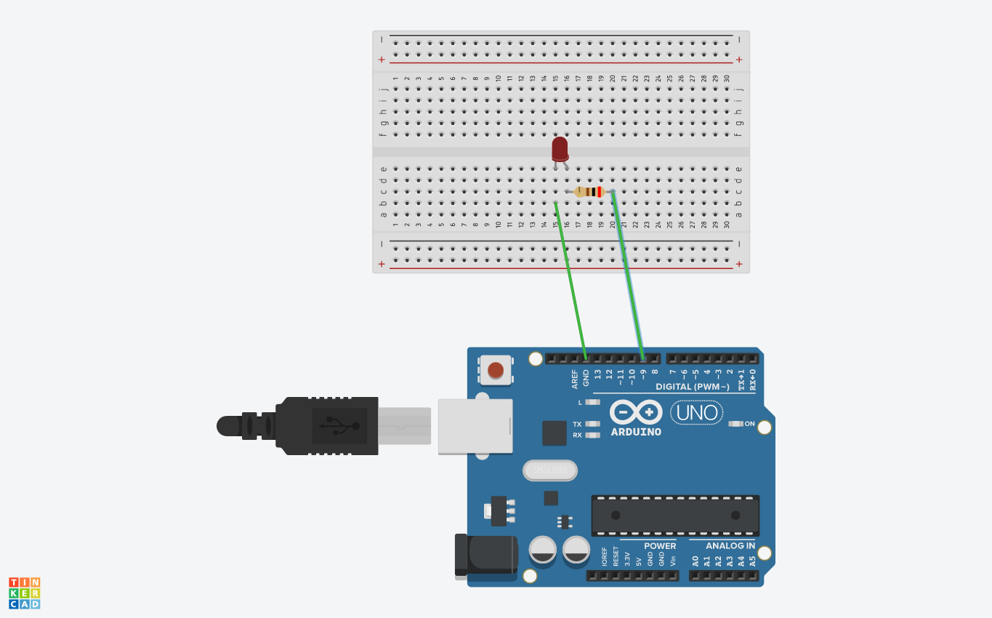

Led- Flasher code:

void setup()  
{  
 pinMode(9, OUTPUT);  
   
}  
  
void loop()  
{  
 digitalWrite(9, HIGH);  
 delay(1000); //Wait for 1000 milliseconds  
 digitalWrite(9, LOW);  
 delay(1000); //wait for 1000 milliseconds  
}

**LEARNING AND OBSERVATIONS:**

After verifying and uploading the code that you have coded we can observe that the led starts glowing and after few milliseconds it again turn off.

**PROBLEMS AND TROUBLESOTING:**

You should take care whether the board in the arduino\uno or not and also selection of port in tools. This is the main problem where we get confusion

**PRECAUTIONS:**

While installing led in bread board we should take care whether the terminals of led connected or not. The two terminals should not be connected. Install the wires properly in both bread board and arduino board.

**LEARNING OUTCOMES:**

With this experiment we can learn how to blink led with the help of coding. In this experiment we are not using any battery. Arduino board provide sufficient voltage and current to the bread board and with the help of bread board led utilize voltage and current and it starts glowing.

**EXP-2_LED_CHASER**

**THEORY:**

Take 1 breadboard, 5 LED’S, 1 Arduino board and 11 wires. Install 5 led’S in breadboard in such a way that their ‘n’ terminals are connected and ‘p’ terminals should not be connected. By taking 5 wires connect all ‘n’ terminals and from there take another wire and connect it to the ground of digital pins in arduino board . Now take another 5 wires and connect to the ‘p’ terminals of led’S such that every ‘p’ terminal contain 1 wire. Now take all the 5 wires of ‘p’ terminal and connect any 5 pins of arduino board.

CIRCUIT DIAGRAM:

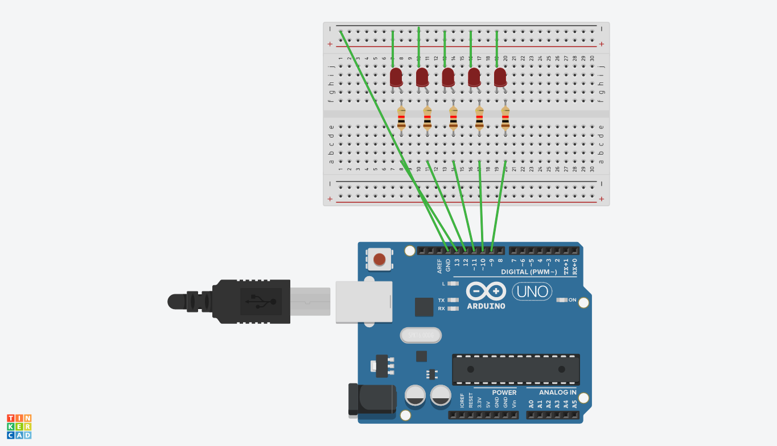

LED_CHASER CODE:

void setup()  
{  
 for (int i=9; i<=13; i++)   
 {  
 pinMode(i, OUTPUT);  
 }  
}  
void loop()  
{  
 for (int i=9; i<=13; i++)   
 {  
 allLEDsOff();  
 if (i!=13)  
 {  
 digitalWrite(i,HIGH);  
 digitalWrite(i+1,HIGH);  
 delay(200);  
 }  
 else  
 {  
 digitalWrite(i,HIGH);  
 digitalWrite(i-3,HIGH);  
 delay(200);  
 allLEDsOff();  
 }  
 }  
}  
  
void allLEDsOff(void)  
{  
for (int i=9; i<=13; i++)   
 {  
 digitalWrite(i, LOW);  
 }  
delay(100);  
}

LEARNING AND OBSERVATIONS:

After verifying and uploading the code that you have coded we can observe that the led’S starts glowing in such a way that if 1,2 led’S 4 are ON then remaining led’s are OFF and if 2,3 led’S are ON then remaining led’s are OFF and if 3,4 led’S are ON then remaining led’s are OFF and if 4,5 led’S 4are ON then remaining led’s are OFF and if 5,1 led’S are ON then remaining led’s are OFF . It starts working like this.

**PROBLEMS AND TROUBLESHOOTING:**

You should take care whether the board in the arduino\uno or not and also selection of port in tools. This is the main problem where we get confusion

PRECAUTIONS:

While installing led’s in bread board we should take care whether the ’n’ terminals of led’s connected or not.Here the ‘n’ terminals should be connected similarly, we should check whether the ‘p’ terminals are connected or not.In this case ‘p’ terminals should not be connected . Install the wires properly in both bread board and arduino board.

**LEARNING OUTCOMES:**

With this experiment we can learn that how led’s are blinking in such a way that 1,2 & 2,3 & 3,4 & 4,5 & 5,1.These are all the positions at which led’s blinks.This is the step by step process.